# Chapter 4 System Design

## 4.1 Overview of P.A.C.E System Architecture

The Website is built in 3 simple parts/layers that contains the frontend, Backend and Database. 

**Frontend (Client Side):** Frontend is the part users see and use like buttons, colours, forms and pages etc. client side means when a user wants to use the platform or website whatever he sees, and he do from his side it comes under the client-side process. This frontend is developed using the React.js, responsible for the user interface.  Users can:

* View and complete sustainability actions
* Earn points and rewards
* Compete on leaderboards
* Control their profile and their past.

**Backend (Server Side):** It is the part that works in the background, handling tasks like saving data and checking login details. It is build using the Node.js and express.js. It is nothing but a mediator which connects the front end with the database and process requests from the front end to store in the database like checking login details, saving donations, and calculating points.  Authentication: A user is allowed to log in successfully with email and password. JWT (JSON Web Tokens) are provided with different access to regular users and admins.

* Database: Supabase (PostgreSQL) is used in the site and it is where structured data is stored in the form of users, actions, points and rewards.
* Live activity: It can be used to track and update the activity in real-time with WebSockets and Cloud Messaging.
* Analytics and Reports: Live reporting systems are used to generate SDG document.
* API Integration: APIs enable the mobile app and the site to have the same real-time data hence actions performed on one platform are reflected to the other.

**Database (Where data is stored):** The database is where all the information like donations, user account details, forms and page details will store safely in the form of tables. Every table contains table names, Rows, Columns. This website stores the data in Supabase, which helps manage the data properly and update things in real time.

**Security and Privacy:**

Security was a great point:

* All information is encrypted (while stored as well as while shared).
* 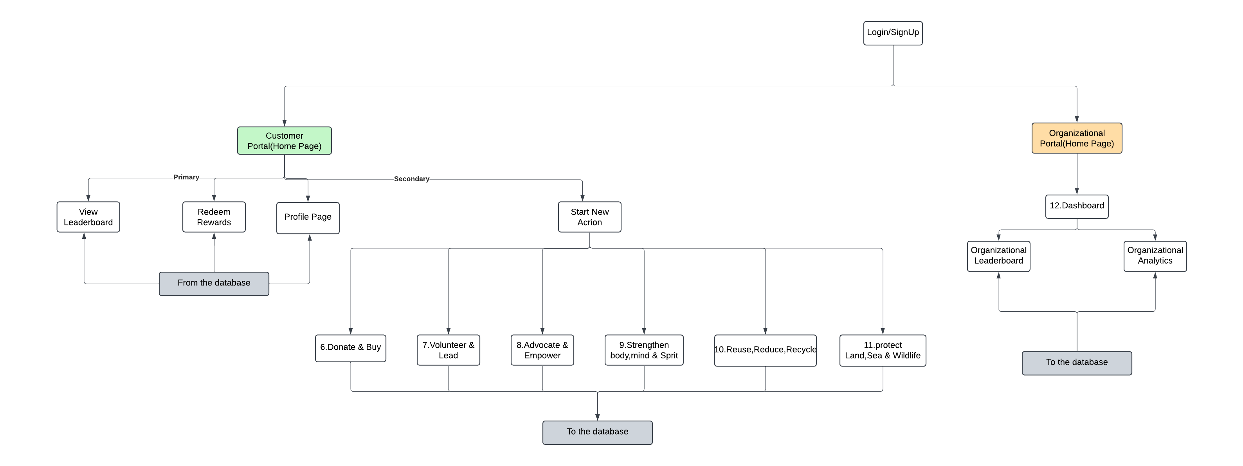Role-based access prevents unauthorized access.

## 4.2 Updated Website Layout and Workflow

The site is divided into two large parts, User Dashboard and Admin Dashboard

**User Dashboard Features:**

* Home Page: Introduces a welcome text with 6 Action circular buttons with good animation and with only 3 buttons-Start Here, View Leaderboard and Redeem Rewards to make user life simpler.
* Start Here: The user is given a list of all the available sustainability activities(2 activities per category/action).
* View Leaderboard: Displays rankings of top-performing users with Rank, Badge, Name, Email and points they earned in total. This page also have the Badge info which gives idea to users how they are consider as that particular badge holders.
* Rewards Page: This is a page that shows what one can get based on the number of activities they involved and the points they earned through it. Different rewards will be awarded for each activities.
* Profile: The user can view his/her profile and his/her achievements.

**Admin Dashboard Features:**

The Admin Dashboard will allow managers, team leads, and sustainability officers to track company-wide progress on SDG goals, view detailed reports, and monitor employee participation.

* Dashboard Overview: Shows SDG performance of the company at the company level in the form of a Pie Charts, Horizontal Bar Chart and mini trends (Graphs).
* Reports: Real-time performance reports and downloadable summaries in word format.
* User Management: Admins can also view all the information of the individual users.

Development Workflow:

The architecture was derived based on a SCRUM process:

* The entire project was split into user side and the corporate side.
* It was broken down into the smaller portions in each page and drawn sprint-by-sprint on every side.
* Weekly meetings with the professor and app developer were organized to keep track of the progress and rectify.
* Changes including: were guided by the many tests and feedback (user comments) by the users like sample students.
  + - * + Elimination of the conventional navigation bar.
        + To facilitate ease of navigation, an inclusion of one Start Here button.
        + A suggestion to use a smiley voice to introduce and AI-based activity recommendations.

Design Evolution

* The first designs were created in low-fidelity paper sketches (of the order of 15 pages).
* They have been built as high-fidelity mockups in Figma and layout tools like Lucid chart.
* Feedback was responded to in the process of test use and when a review of the design was being undertaken.